The Mystery of the Tangled Tinsel

Instructions
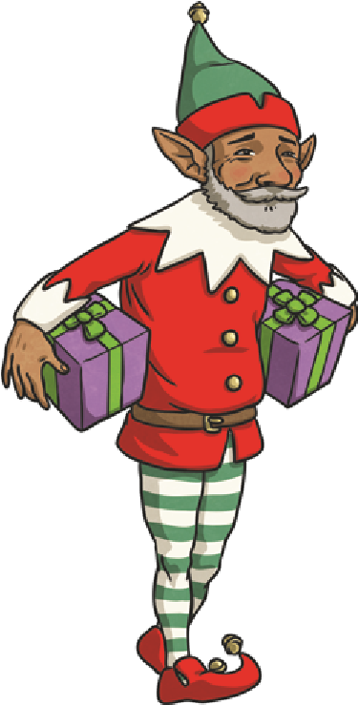
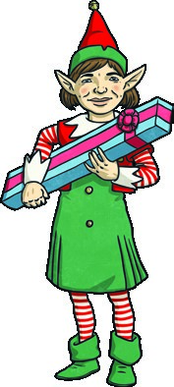
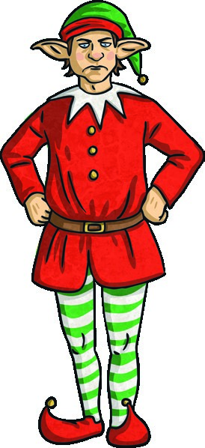
A serious crime has been committed in Lapland. It is a week before Christmas and Santa is getting ready for the big light switch on tomorrow evening, but the lights and decorations have been found in a terrible tangle.
As the Detective Chief Inspector, it is your job to find out who has ransacked the decorations. Your officers have taken down the names and descriptions of the 30 elves who were tasked with decorating the town and, most importantly, the giant Christmas tree.

There are also five top secret clues that have been left. To crack the case, you will need to solve each clue and check the information with the list of names. Good luck!
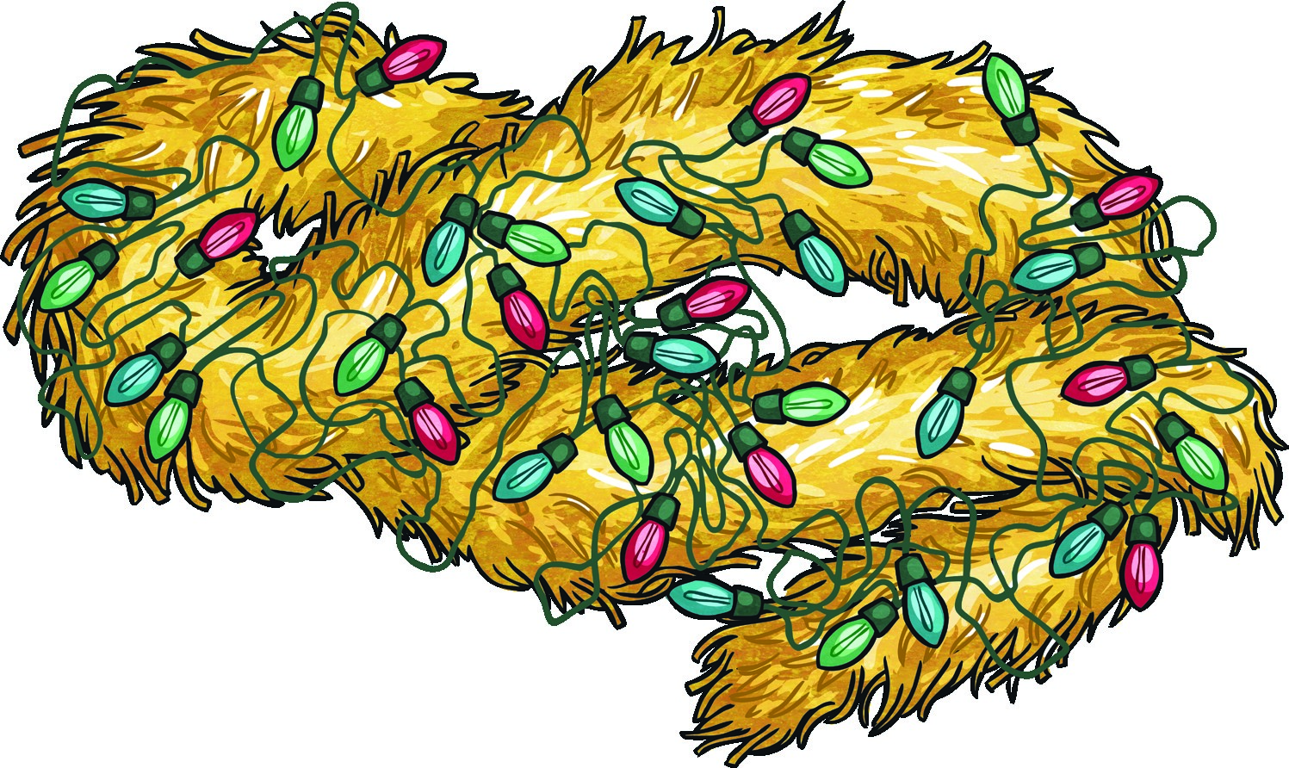

The Elf Descriptions
Elf Name | Male or Female | Job in the Workshop | Colour of Outfit | Height (for an elf!) | Favourite  Christmas  Decoration
Angel Applepie | F | manufacturing | red | short | angels
Bubble Bell | M | loading | green | tall | bells
Christy Cheer | M | loading | blue | medium | angels
Cookie Candy | F | designing | green | short | baubles
Dazzle Droopysocks | M | wrapping | yellow | medium | angels
Delight Dimples | F | loading | blue | medium | stars
Elfina Evergreen | F | manufacturing | blue | short | bells
Elvis Elf | M | designing | yellow | medium | baubles
Fizz Frosty | M | designing | yellow | short | bells
Glitter Glimmer | F | wrapping | blue | tall | angels
Glow Gleam | M | wrapping | red | medium | bells
Holly Happy | F | manufacturing | yellow | tall | angels
Ivy Imp | F | loading | green | tall | bells
Jolly Jingle | M | manufacturing | red | tall | bells
Joy Jangle | F | designing | blue | short | baubles

The Elf Descriptions
Elf Name | Male or  Female | Job in the Workshop | Colour of Outfit | Height (for an elf!) | Favourite  Christmas  Decoration
Kris Kristingle | M | manufacturing | green | medium | bells
Lulu Love | F | loading | green | tall | stars
Merry Miracle | F | designing | yellow | medium | stars
Noel Nipper | M | manufacturing | green | tall | bells
Poinsettia Pine | F | wrapping | yellow | tall | baubles
Pompom Partypie | M | manufacturing | red | tall | bells
Rudy Ribbon | M | manufacturing | yellow | medium | stars
Sparkle Star | M | loading | blue | short | bells
Snowflake Satin | F | wrapping | green | short | angels
Sugarplum Shimmer | F | designing | red | medium | stars
Tinsel Tazz | M | designing | green | short | stars
Tiny Twinkletoes | M | manufacturing | red | tall | bells
Topper Tumbles | M | manufacturing | red | short | bells
Winter Wonder | F | wrapping | blue | tall | angels
Yule Yummy | M | loading | green | medium | baubles
The tinsel tangler was Clue 1 - Advent Adverbials
The elves have been writing about Christmas but some have forgotten where the commas should be! Check which ones are correct. If they are, give them a tick. If they are incorrect, give them a cross. If you have more ticks, the culprit is a female.
If you have more crosses, the culprit is a male.
Advent Adverbial | ✓ or x
While, we make the presents we often sing together.
Late on Christmas Eve, Santa can be seen flying through the sky.
With care and attention all of the presents are made, in Santa’s workshop.
Like beautiful jewels the lights, sparkle on Santa’s giant Christmas tree
Flying across the sky, Santa and the reindeer rush to deliver all the gifts in time.
Under the tree lots of beautifully wrapped presents, wait to be opened.
After a busy night Santa, and the reindeer enjoy a long holiday.
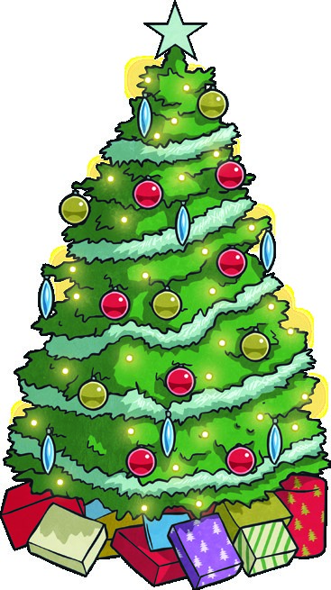
There were crosses and ticks. There were more so the culprit is male / female.
Clue 2 - Magical Maze!
Find your way through this maze of Y5/6 statutory spelling words. By following the path (vertically or horizontally) of correctly spelled words, you will find out what the culprit’s favourite Christmas decorations are.
Start
forty | recommend | acompany | availible | vehical | comunity | prejudis
relavent | shoulder | communicate | programme | determined | stomach | variaty
symbal | lightnning | imediate | thorugh | perswade | foreign | langwage
amature | rythm | neighbor | restaurant | temperature | yacht | harrass
averige | cemetary | twelth | system | excellant | neccessary | equiped
vegtable | espesially | hindrence | identity | frequently | parliament | exaggerate
critisize | privilige | aparent | ocupy | proffession | signiture | muscle
consience | pronunciation | achieve | equip | committee | disastrous | queue
develope | leisure | sudgest | equiptment | bargin | bruize | convinience
definate | individual | ancient | secretary | desperate | marvelous | recognize
consious | curiousity | orkward | explaination | sincere | sufficient | nusance
corespond | acording | sacrifise | goverment | agressive | dictionary | familiar
embarrass | mischevious | rhyme | phisycal | guarantee | enviroment | controversy
stars |  | baubles |  | angels |  | bells
 |  | 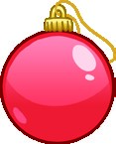 |  |  |  | 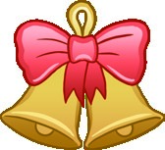
The culprit’s favourite Christmas decorations are
.
Clue 3

Santa’s Relative Clauses
Santa has been reading the police descriptions of the elves but has noticed that many of the relative pronouns are missing! Can you fill in the gaps with who, whose or which?
If you use who most, the culprit is short.
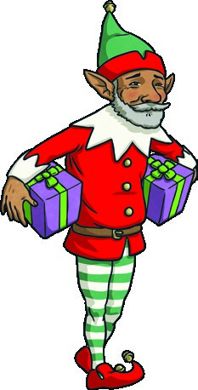
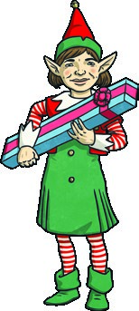
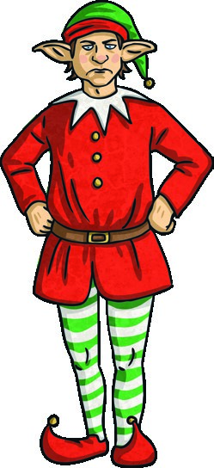
If you use whose most, the culprit is medium.
If you use which most, the culprit is tall.
Sentence with Relative Pronoun Missing | Who, Whose or Which?
Elvis Elf, wears a yellow outfit, works in the design section.
Poinsettia Pine, favourite Christmas decorations are baubles, is remarkably tall for an elf.
Snowflake Satin wears a green outfit, is too big for her because she is quite short.
Delight Dimples collects stars, are her favourite Christmas decorations.
Lulu Love, ______ is very tall, is usually given the job of putting the star on top of the Christmas tree.
Angel Applepie always wants to put angels, are her favourite decoration, at the top of tree.
Glitter Glimmer wears a blue outfit, is a bit short on her because she is exceptionally tall for an elf.
I used who times.
I used whose times. I used which times.
I used most so the culprit is short / medium / tall.
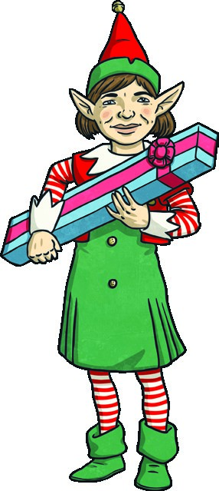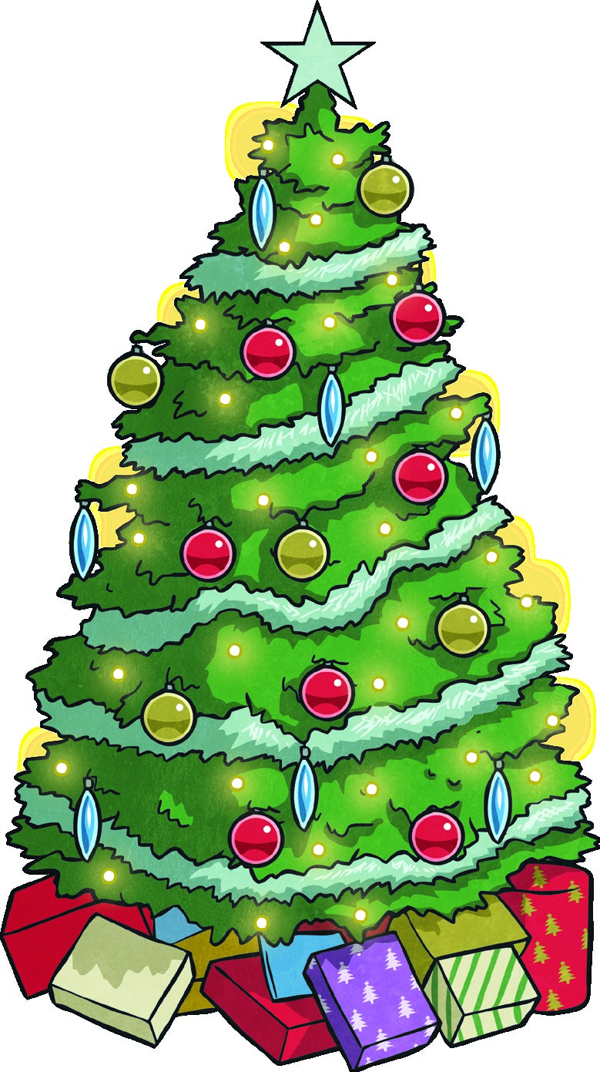
Clue 4 - Silly or Sensible Synonyms?
Match the words the silly elves use to describe their jobs to the actual job titles. Whichever one has the most synonyms is the job of the culprit.
planning producing making bundling packing
constructing tying sketching assembling
building drafting
Designing
Manufacturing
Wrapping
Loading
The word with the most synonyms is , so that is the culprit’s job in the workshop.

Clue 5 - Present Prefixes
With all the chaos this police investigation has caused, these presents have been muddled up! In order to help sort them for delivery, you need to match them to the correct verb prefix.
Whichever verb prefix has the most words with it will reveal the colour of the culprit’s outfit.
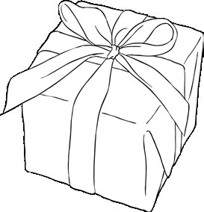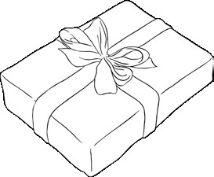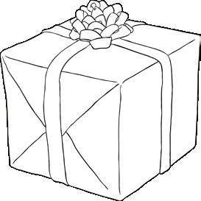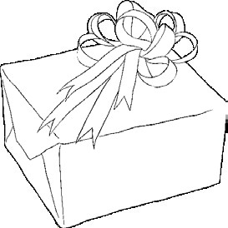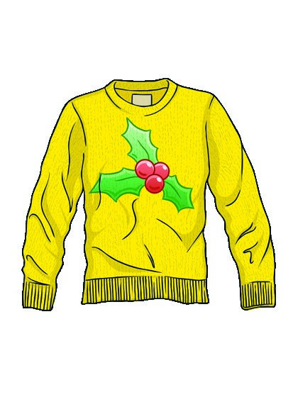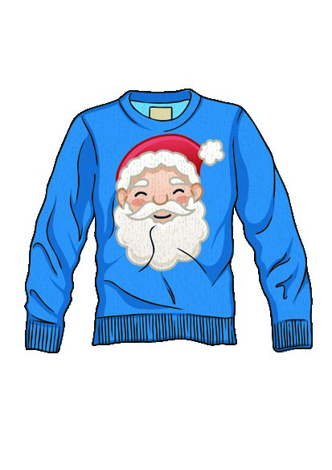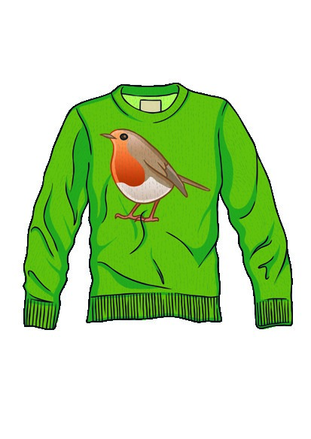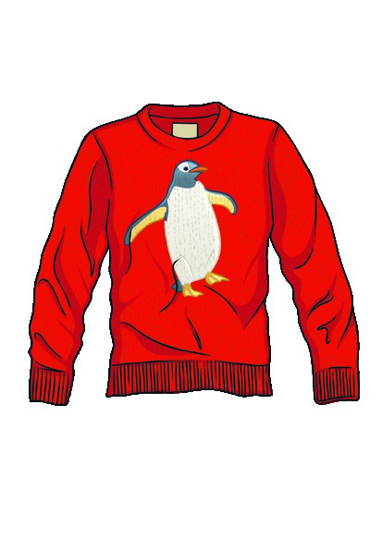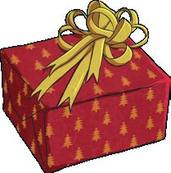
appoint
fuse
treat
read
come
sleep
connect
code
spell
act
flow
courage
place
estimate
dis-
de-
over-
mis-
The prefix I used the most was

,

so the culprit’s outfit is

.

Clue 1 - Advent Adverbials Answers
Advent Adverbial | ✓ or x
While, we make the presents we often sing together. | x
Late on Christmas Eve, Santa can be seen flying through the sky. | ✓
With care and attention all of the presents are made, in Santa’s workshop. | x
Like beautiful jewels the lights, sparkle on Santa’s giant Christmas tree | x
Flying across the sky, Santa and the reindeer rush to deliver all the gifts in time. | ✓
Under the tree lots of beautifully wrapped presents, wait to be opened. | x
After a busy night Santa, and the reindeer enjoy a long holiday. | x
There were 5 crosses and 2 ticks.
There were more crosses so the culprit is male / female.

Clue 2 - Magical Maze! Answers
Start
fo | rty | recommend |  |  | acompany | availible |  | vehical |  | comunity |  | prejudis
relavent |  | shoul |  | der | communicate | programme |  | determined |  | stomach |  | variaty
symbal |  | lightnning |  |  | imediate | thorugh |  | perswade |  | for | eign | langwage
amature |  | rythm |  |  | neighbor | restaurant |  | temperature |  | ya | cht | harrass
averige |  | cemetary |  |  | twelth | sys | tem | excellant |  | neccessary |  | equiped
vegtable |  | espesially |  |  | hindrence | ide | ntity | frequently |  | parliament |  | exaggerate
critisize |  | privilige |  |  | aparent | ocupy |  | proffession |  | signiture |  | mu | scle
consience |  | pronunciation |  |  | achieve | equip |  | committee |  | disastrous |  | qu | eue
develope |  | lei | sure |  | sudgest | equiptment |  | bargin |  | bruize |  | convinience
definate |  | indi | vidual |  | ancient | secretary |  | desperate |  | marvelous |  | recognize
consious |  | curiousity |  |  | orkward | explaination |  | sin | cere | sufficient |  | nusance
corespond |  | acording |  |  | sacrifise | goverment |  | agressive |  | dicti | onary | familiar
embarrass |  | mischevious |  |  | rhyme | phisycal |  | guarantee |  | enviroment |  | contr | oversy
stars |  |  |  |  | baubles |  |  | angels |  |  |  | bells
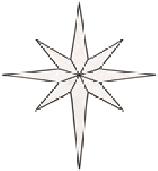 |  |  |  |  |  |  |  | 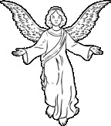 |  |  |  | 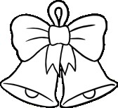
The culprit’s favourite Christmas decorations are bells.
Clue 3
Santa’s Relative Clauses Answers
Sentence with Relative Pronoun Missing | Who, Whose or Which?
Elvis Elf, wears a yellow outfit, works in the design section. | who
Poinsettia Pine, favourite Christmas decorations are baubles, is remarkably tall for an elf. | whose
Snowflake Satin wears a green outfit, is too big for her because she is quite short. | which
Delight Dimples collects stars, are her favourite Christmas decorations. | which
Lulu Love, ______ is very tall, is usually given the job of putting the star on top of the Christmas tree. | who
Angel Applepie always wants to put angels, are her favourite decoration, at the top of tree. | which
Glitter Glimmer wear a blue outfit, _______ is a bit short on her because she is exceptionally tall for an elf. | which
I used who 2 times.
I used whose 1 time.
I used which 4 times.
I used which most so the culprit is short / medium / tall.
Clue 4 - Silly or Sensible Synonyms?
Answers
planning
sketching
drafting
making
producing
assembling
constructing
building
packing
bundling
tying
Designing
Manufacturing
Wrapping
Loading
The word with the most synonyms is manufacturing, so that is the culprit’s job in the workshop.
(Some children might place packing with wrapping, which is also a possible synonym.)

Clue 5 - Present Prefixes Answers
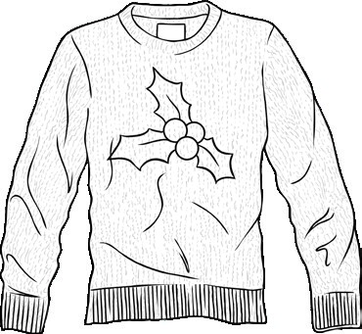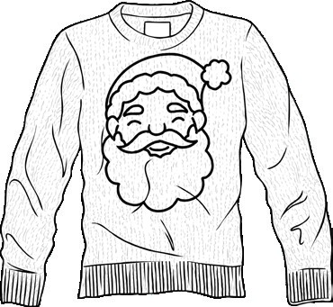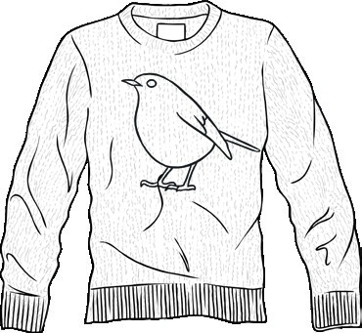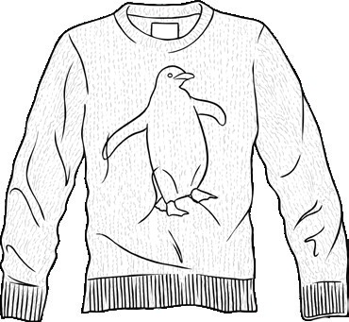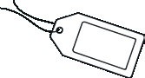
yellow
blue
green
red
dis- | de- | over- | mis-
appoint connect courage | fuse  code | come sleep act  flow estimate | treat read spell place
The prefix I used the most was over-, so the culprit’s outfit is green.
The tinsel tangler was Noel Nipper.

