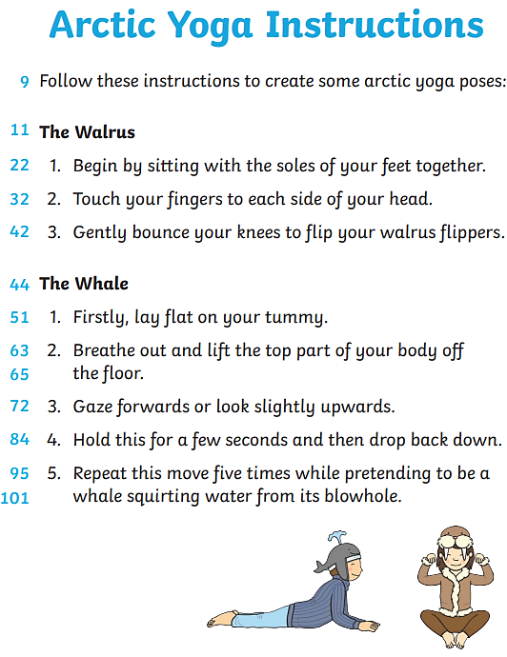

Questions

Infer
- Do you think this is a fiction or non-fiction text?

Retrieve
- Which parts of your feet must touch together to?
do the walrus pose?

Vocabulary
- Which word has the author used instead of ‘look’ in the whale instructions?

Explain
- Why are these exercises called Arctic yoga poses?

Predict
- Do you think that you would be good at Arctic yoga? Why or why not?

.

