Maths | English | Reading | Topic/Science
Weekly Focus:  Year 3:  Year 4: Division  (please watch the videos and complete the worksheets) | Weekly Focus: Journey – by Aaron Becker  Link to the story:  https://www.youtube.com/watch?v=kWqhNpjvcSs​ | Text/s:  Operation Gadgetman | Topic Unit: The Stone Age  Science Unit: States of Matter
Monday:  Year 3 : To divide with remainders  https://vimeo.com/492449125  **complete worksheet on the bottom of home learning plan**  Year 4 : Divide 2 digits by 1 digits (recap)  https://vimeo.com/492601303  https://assets.whiterosemaths.com/fixed/res/2019/11/Y3-Spring-Block-1-WO6-Divide-2-digits-by-1-digit-2-2019.pdf | Monday:  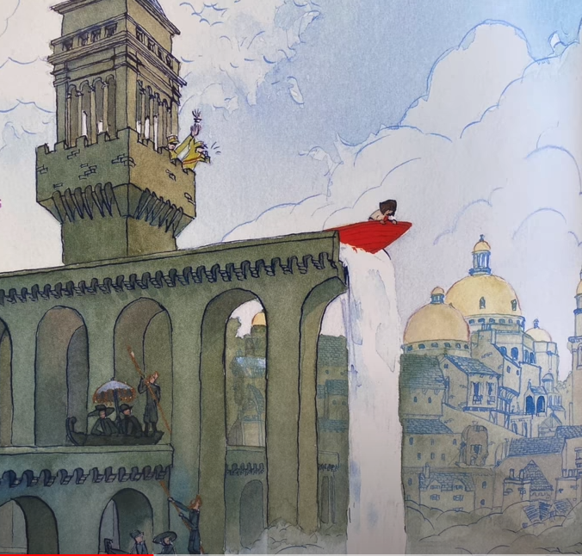  Look at the picture. Think of alliterations to describe how she dropped/fell. Write a sentence including this phrase.  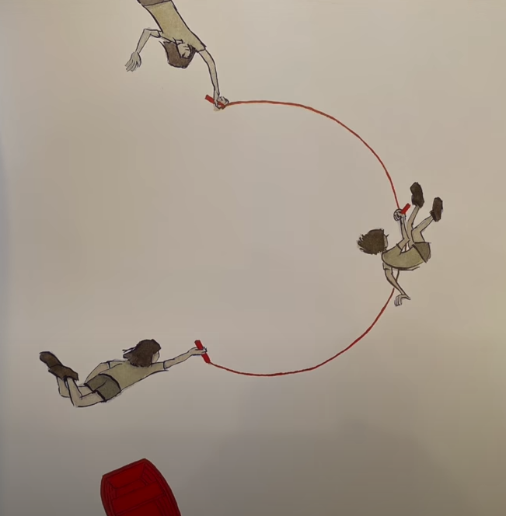  Draw the balloon as quickly as you can. Think of words showing how she drew it ( e.g. frantically ) Write a sentence including this.  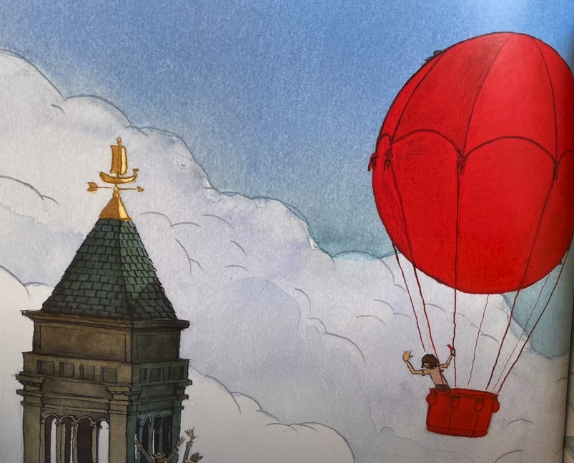  Write a simile and include it in a sentence to describe how she drew the balloon.  e.g. As quick as the flick of a witch’s wand, she flew high up into the empty sky. | Monday:  Guided Reading:  Operation Gadgetman | Monday:  Forest School:  Go outside and collect leaves and twigs. Use them to build a shelter that a hedgehog or other small animal could shelter in.
Tuesday:  Year 3: To divide 2 digits by 1 digit.  https://vimeo.com/494126561  https://assets.whiterosemaths.com/fixed/res/2019/11/Y3-Spring-Block-1-WO7-Divide-2-digits-by-1-digit-3-2019.pdf  Year 4: To divide 2 digits by 1 digit.  https://vimeo.com/497573248  https://assets.whiterosemaths.com/fixed/res/2019/12/Y4-Spring-Block-1-WO8-Divide-2-digits-by-1-digit-1-2019.pdf | Tuesday:  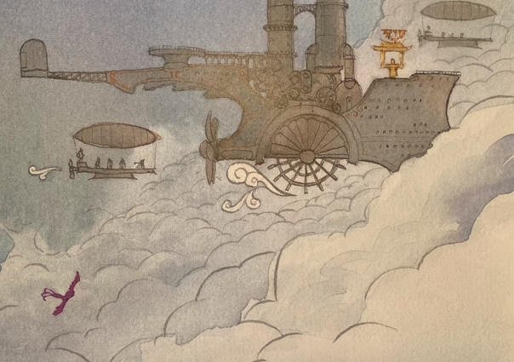  Think of prepositions to describe where the bird was and include in a sentence.  e.g.. Above her, a majestic bird flew.  Think of a simile to describe the bird flying.  e.g.. Its tail fluttered like ribbons as it dived in an out of the clouds like a needle running through cloth.  Listen to some birdsong. Write a simile to describe the sound.  e.g. Its sweet song twinkling like raindrops in a stream. | Tuesday:  Guided Reading:  Operation Gadgetman | Tuesday:  PE: Joe Wicks  Choose a video and complete the workout  https://www.youtube.com/playlist?list=PLyCLoPd4VxBuS4UeyHMccVAjpWaNbGomt
Wednesday:  Practise your times tables  Play on Times Table Rock Stars for 30 minutes  Make yourself a poster with the times tables you are finding the most challenging to help you remember them | Wednesday:  Think of negative onomatopoeia words to describe the metallic zeppelin.  E.g. clash, screech, clang  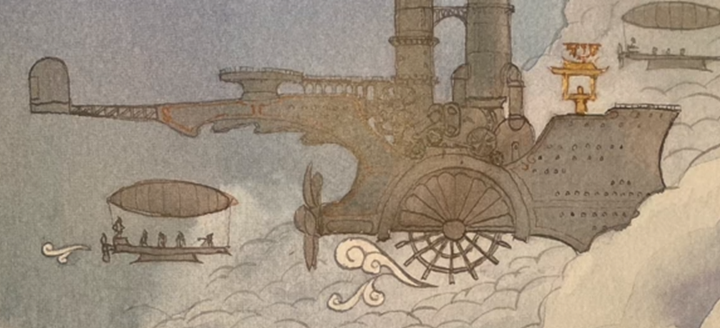  Think of synonyms for pushed.  E.g. shoved  Write a sentence do describe the zeppelin.  E.g. A zeppelin, all smoke, and silver, and ugliness. | Wednesday:  Reading for pleasure: read your book for 20 minutes | Wednesday:  Spend afternoon doing something you really enjoy doing – let us know what you choose!
Thursday:  Year 3: To practice scaling.  https://vimeo.com/494127943  https://assets.whiterosemaths.com/fixed/res/2019/11/Y3-Spring-Block-1-WO8-Scaling-2019.pdf  Year 4: To divide 2 digits by 1 digit  https://vimeo.com/497601665  https://assets.whiterosemaths.com/fixed/res/2019/11/Y3-Spring-Block-1-WO7-Divide-2-digits-by-1-digit-3-2019.pdf | Thursday:  Watch the video and make notes of how the men would attempt to catch the bird  https://www.youtube.com/watch?v=sj6-LG5VpGk  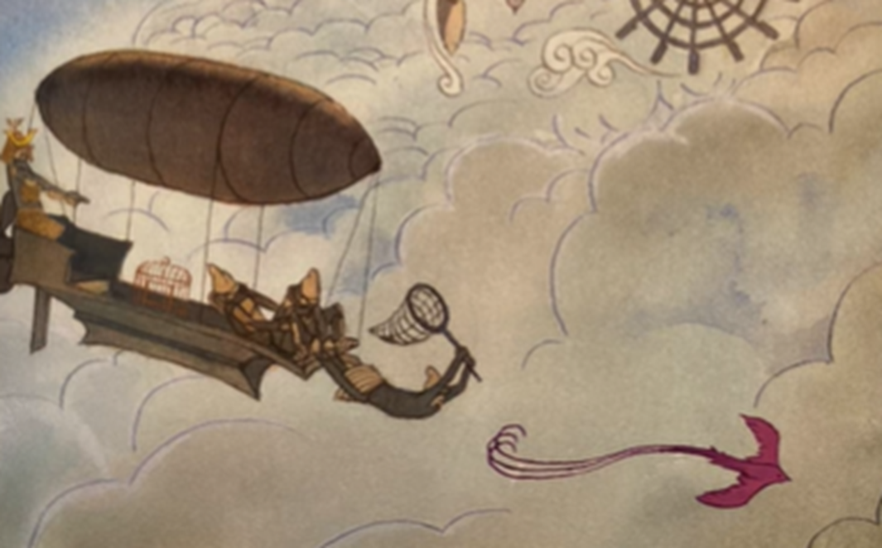  Describe how you would feel when you know something bad is about to happen.  E.g butterflies in your tummy  How would you be feeling? Write down how you think the girl would be feeling watching the bird being caught? | Thursday:  Guided Reading:  Operation Gadgetman | Thursday:  Science  Watch the video below:  What happens when you heat or cool each state of matter.  https://classroom.thenational.academy/lessons/what-happens-when-you-heat-or-cool-each-state-of-matter-68w3at
Friday:  Year 3: To investigate different combinations.  https://vimeo.com/496812718  https://assets.whiterosemaths.com/fixed/res/2019/11/Y3-Spring-Block-1-WO9-How-many-ways_-2019.pdf  Year 4: To divide 2 digits by 1 digit  https://vimeo.com/497936690  https://assets.whiterosemaths.com/fixed/res/2019/11/Y4-Spring-Block-1-WO9-Divide-2-digits-by-1-digit-2-2019.pdf | Friday:  How is the bird moving to get away?  E.g. zig-zagged  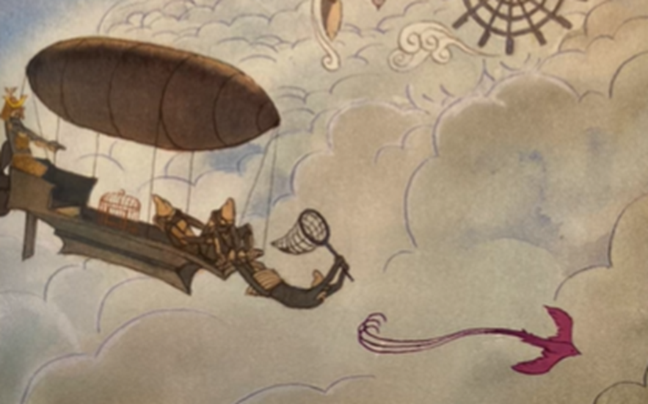  Think of synonyms for feeling trapped.  E.g. captured  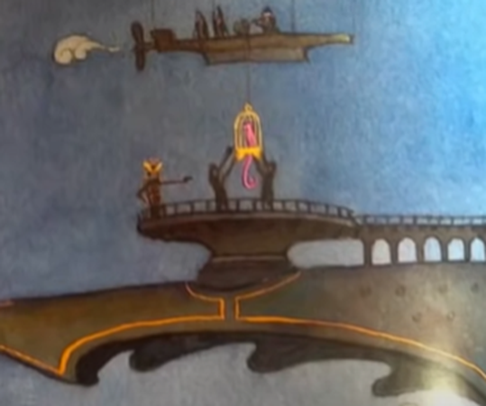  How would the girl approach the zeppelin? E.g. quietly floating  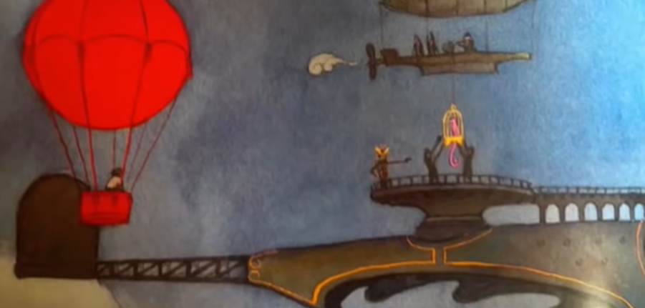 | Friday:  Reading comprehension (see class page on website) | Friday:  PSHE:  Watch newsround and complete quiz.  https://www.bbc.co.uk/newsround/news/watch_newsround

