Tuesday 1st March
To describe what it was like in London during the Great plague of 1665
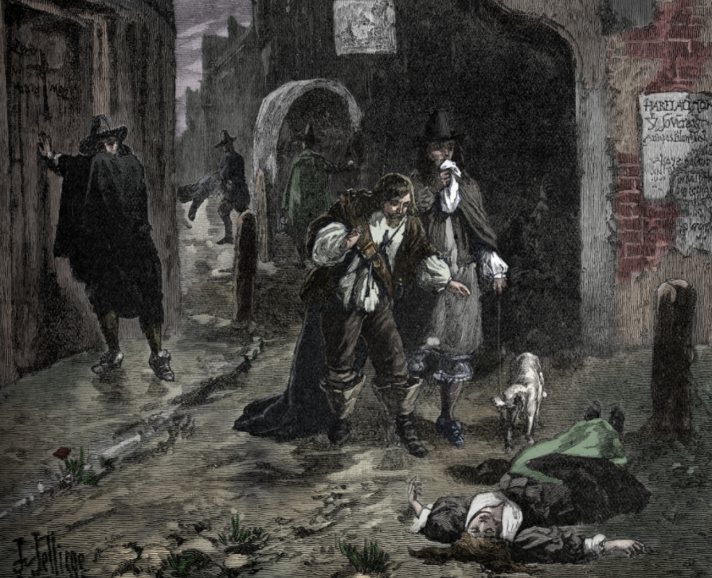

Using the lines in your books describe what you can see in the picture.
I can see ………
Challenge - What would you be able to hear and smell?

