Date:
L.O. To explore the Arctic Circle and identify the countries within it.
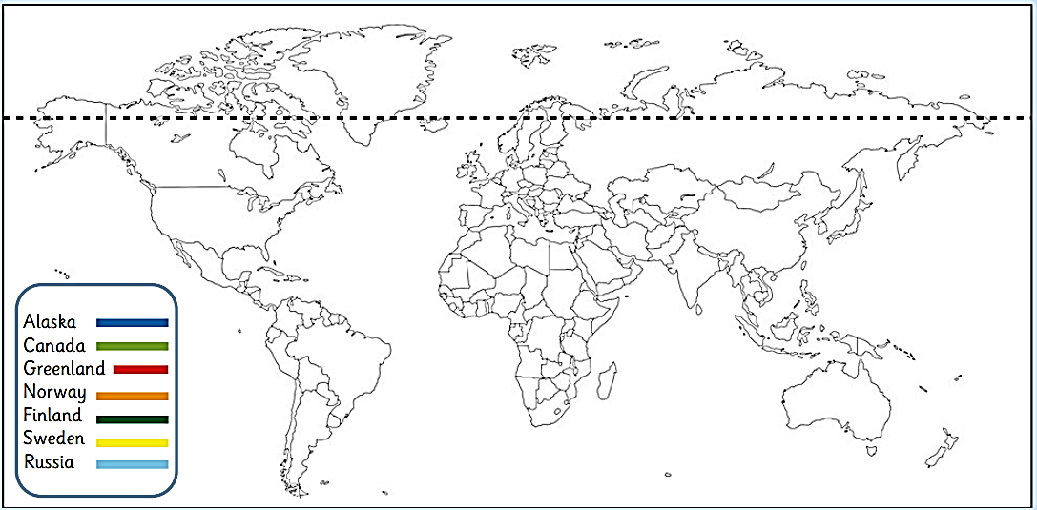
Use the Arctic Circle Map to help you colour the countries that are partly inside the Arctic Circle.

Can you answer the questions?
How many countries are in the Arctic Circle? _____________
Which country is next to Alaska? _____________________
Is Africa in the Arctic Circle? __________ How do you know? ________________________________________________________________

