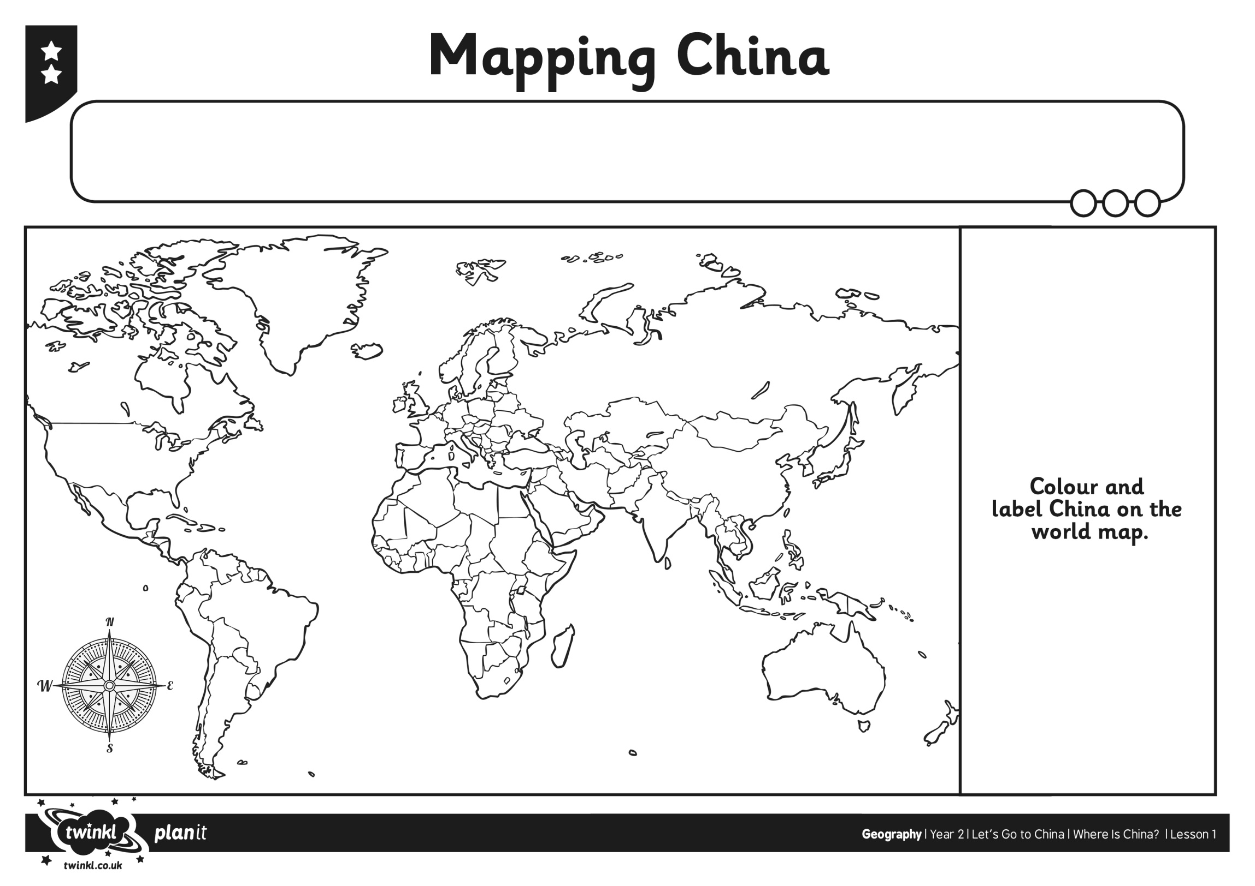

Place Paddington in China on the world map

Can you label?

* The Capital city
* An ocean nearby

Date:

L.O. To locate China on a world map