Maths | English | Reading | Topic/Science
Weekly Focus:  Year 1: Multiplication and Division  Year 2: Shape | Weekly Focus:  To write a story opening.  Please click on the links and watch the videos. | Text/s:  The 3 Billy Goats Comprehension | Topic Unit:. The Plague  Science Unit:  Year 1 : Everyday materials  Year 2: Plants
Monday:  Year 1: Counting in 2s  https://vimeo.com/521501160  https://assets.whiterosemaths.com/fixed/res/2019/12/Y1-Spring-Block-2-D8-Count-in-2s-2019.pdf  Year 2-  https://vimeo.com/514239683  https://assets.whiterosemaths.com/fixed/res/2019/12/Y2-Spring-Block-3-WO12-Make-patterns-with-3D-shapes-2019.pdf | Monday:  https://classroom.thenational.academy/lessons/to-box-up-for-purpose-65jp4t | Monday: Lesson 1  Please download the text and answer the questions. | Monday:  Year 1  Materials –What are objects made from?  https://classroom.thenational.academy/lessons/what-are-objects-made-from-61gp8d  Year 2- Plants  https://classroom.thenational.academy/lessons/what-is-the-difference-between-deciduous-and-evergreen-trees-c5j6ar
Tuesday:  Year 1: Counting in 5s  https://vimeo.com/521501660  https://assets.whiterosemaths.com/fixed/res/2019/12/Y1-Spring-Block-2-D9-Count-in-5s-2019.pdf  Year 2:  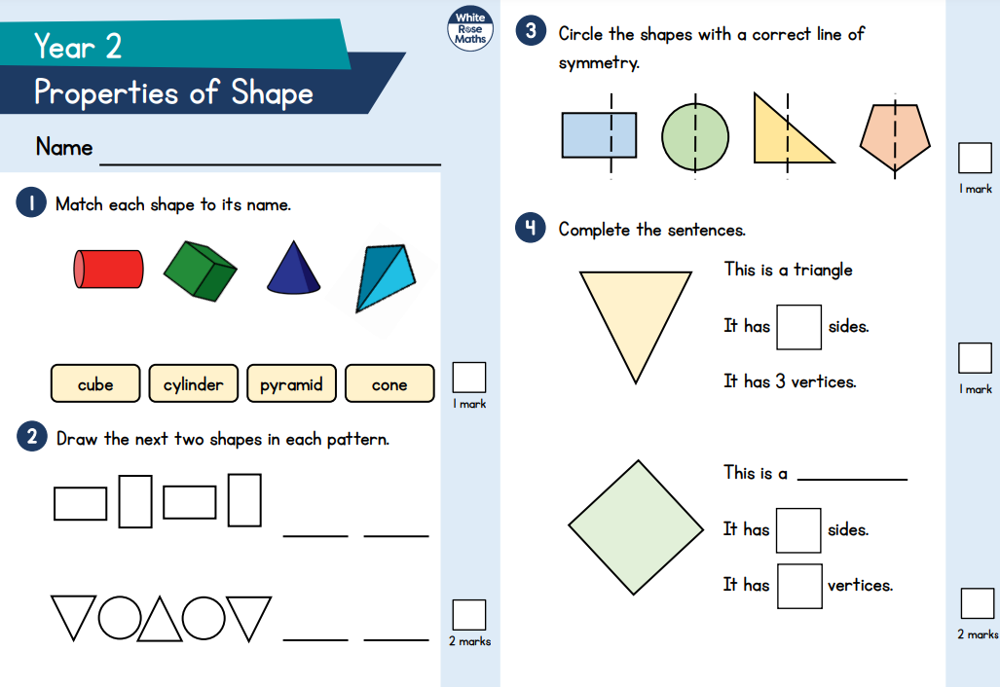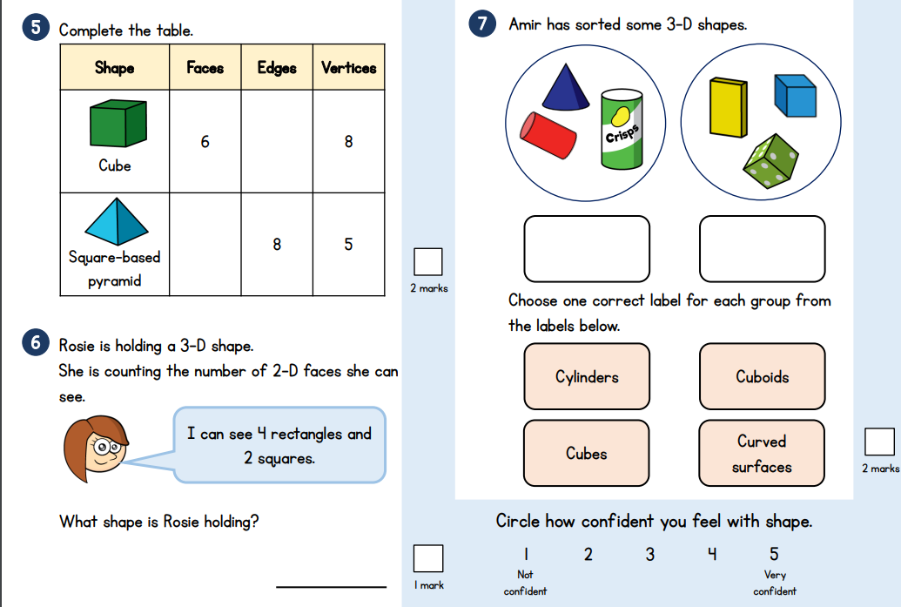 | Tuesday:  https://classroom.thenational.academy/lessons/to-explore-how-writers-create-openings-that-hook-70rp8t | Tuesday:  Lesson 2-  Please download the text and answer the questions. | Tuesday: Topic  LO – To understand how doctors tried to treat the plague and label a picture of a plague doctor.  Please visit the website below to learn about the plague doctor.  Plague doctor  Then download the picture of the doctor and either draw your own or label and colour.
Wednesday:  Year1: counting in 10s  https://vimeo.com/521502841  https://assets.whiterosemaths.com/fixed/res/2020/03/Y1-Summer-Block-1-D1-Count-in-10s-2020.pdf  Year 2: Activity Lesson  https://vimeo.com/516649884 | Wednesday:  https://classroom.thenational.academy/lessons/to-explore-how-writers-create-openings-that-hook-70rp8t | Wednesday:  Handwriting sheet on Class Page | Wednesday: PE  You can choose to take part in a Joe Wicks workout or Cosmic kids yoga on youtube. Alternatively you may choose to go for a bike ride or a jog outdoors.
Thursday:  Year 1: Making equal groups  https://vimeo.com/528943216  https://assets.whiterosemaths.com/fixed/res/2020/03/Y1-Summer-Block-1-D2-Make-equal-groups-2020.pdf  Year 2:  https://vimeo.com/516652833  https://assets.whiterosemaths.com/fixed/res/2020/01/Y2-Spring-Block-4-WO1-Make-equal-parts-2019.pdf | Thursday:  https://classroom.thenational.academy/lessons/to-write-an-opening-that-hooks-action-focus-61j68e | Thursday:  Please download the text and answer the questions. | Thursday:  Art  https://classroom.thenational.academy/lessons/exploring-shadows-and-tone-6hjk0t  Exploring shadows and tone  In this lesson, we will be hunting for shadows and exploring the different ways we can use shadows to inspire our drawings. Later on in the lesson, we will begin to discuss 'tone' and experiment with a range of drawing materials to understand a bit more about this term.
Friday  Year 1: Adding equal groups  https://vimeo.com/528970702  https://assets.whiterosemaths.com/fixed/res/2020/03/Y1-Summer-Block-1-D3-Add-equal-groups-2020.pdf  Year 2:  https://vimeo.com/516654269  https://assets.whiterosemaths.com/fixed/res/2020/01/Y2-Spring-Block-4-WO2-Recognise-a-half-2019.pdf | Friday:  https://classroom.thenational.academy/lessons/to-write-an-opening-that-hooks-character-focus-6cup6e | Friday:  Handwriting sheet on Class Page | Friday: Forest School  Go for a woodland walk and play a game of choice.  Have a look for signs of spring and try to identify snowdrops and daffodils.  Make a small shelter that would be suitable for a hedgehog, and you could find a suitable snack for it.  Have fun!

