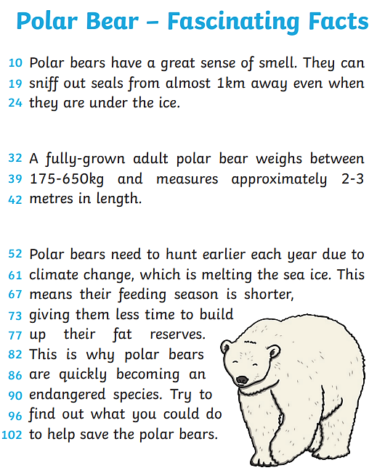

Questions
Retrieve
- How long is an average adult polar bear?

Vocabulary
- Which verb has the author used instead of repeating the word ‘smell’?

Explain
- Why is it important for a polar bear to build up its fat reserves?

Predict
- Where could you look to find out about how to help save the polar bears?

Summarise
- What question could you find the answer to
in this text?

